

COLLEGE OF INFORMATICS AND ELECTRONICS

DEPARTMENT OF MATHEMATICS & STATISTICS

REPEAT ASSESSMENT PAPER

MODULE CODE: MA4005 SEMESTER: Repeat 2006

MODULE TITLE: Engineering Maths T1 DURATION OF EXAM: 2.5 hours

LECTURER: J. Leahy GRADING SCHEME:
Examination: 100%

EXTERNAL EXAMINER: Prof. J. King

INSTRUCTIONS TO CANDIDATES

Answer One (1) question from each Section A and B and any three (3) other questions – Five questions in total. All questions carry equal marks.
-2-

MA4005 Engineering Maths T1

SECTION A

Marks

Q.1. (a) Find the first partial derivatives of the function

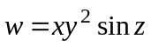 8

- The area, A, of a trapezium is calculated from the formula

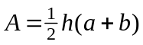

using the measured values 2m, 6m and 8m for h, a and b respectively.

Find using partial differentiation the maximum error in the area as calculated if there is a maximum error of 0.5cm in the measurement of each of h, a and b. 12

Q.2. (a) Evaluate the integrals

- 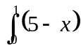 4

- 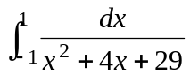 4

- Sketch the graph of 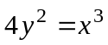 2

and find its length between the points (0,0) and (1,½). 5

Find also the volume generated when the area under this section is rotated about the X-axis. 5

-3-

MA4005 Engineering Maths T1

Q.3. (a) Find the general solutions of the differential equations

- 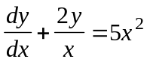

- 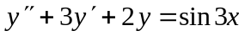 12

(b) The velocity of a moving body at time t is given by the differential equation 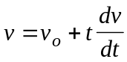

where 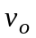 is the velocity when t = 0.

Express v in terms of t and show that the acceleration is a constant by finding 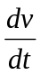. 8

Q.4. (a) Calculate from the defining formula the Laplace transform of

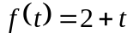 4

- Using the tables find the Laplace transform of the functions

- 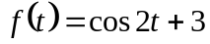 cosh 4t

- 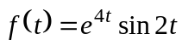 4

- Find the inverse Laplace transform of the function

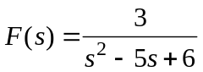 6

(d) Use the Laplace transform to find the solution of the boundary
value problem 6

-4-

MA4005 Engineering Maths T1

Q.5. The function f (x) of period 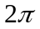 is defined by

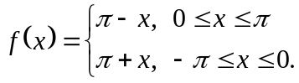

Sketch the graph of f (x) for 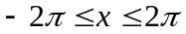 and find the first 4 non-zero terms of the fourier series of f (x). 20

SECTION B

Q.6. (a) Evaluate the determinant

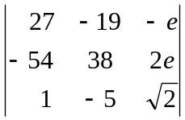 4

- For what values of k has the system

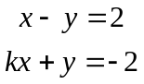

- no solution

- an infinite number of solutions

and (iii) a unique solution 4

- Find the inverse of the matrix 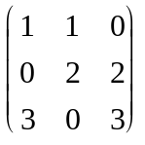

and hence solve the system

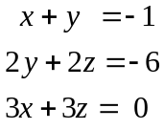 12
-5-

MA4005 Engineering Maths T1

Q.7. (a) State the axioms of a vector space. 5

(b) Determine if the set of all complex numbers of the form
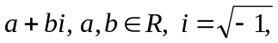 is a vector space under the usual
addition and mutiplication by a scalar. 5

(c) Show the vectors

are linearly independent in 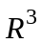. 5

(d) Which of the following are bases for 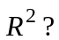

- (1, 0) , (2,-1)
- (0, 0) , (1, 4)
- (1,-7) , (-4,16) 5

Q.8. If 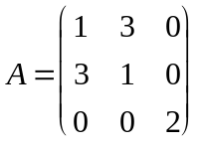 is the matrix representation of a linear transformation 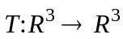

find

- the image of the vector 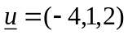 under T 3

- the eigenvalues of A 7

- the rank and nullity of A. 10

TABLE OF LAPLACE TRANSFORMS

f(t) | F(s)
1
 | 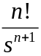
 | 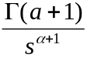
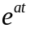 | 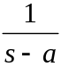
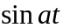 | 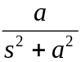
 | 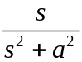
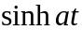 | 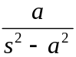
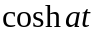 | 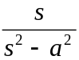
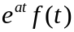 | 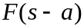
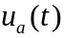 | 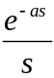
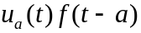 | 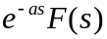
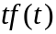 | 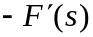
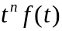 | 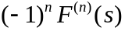
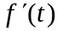 | 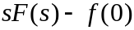
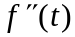 | 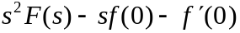
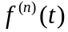 | 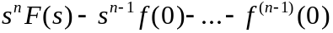
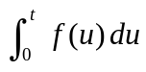 | 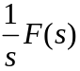
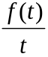 | 